## Exercise 21: Snowman

## Draw a snowman!

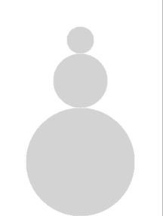

The snowman should have three sections, a bottom snowball with diameter bottom_diameter, a middle snowball with diameter middle_diameter, and a top snowball with diameter top_diameter.

The circles should all be light gray.

The snowman should be centered horizontally in the world, and should be sitting on the bottom of the canvas (You will need to use the canvas_height variable).

*Use variables instead of hardcoded values to create your snowman so that the snowman will always be sitting in the same position no matter the size of the canvas!*

If you are feeling adventurous, can you give the snowman a hat, buttons, or eyes?